**Model Development Phase Template**

|  |  |
| --- | --- |
| Date | 8 July 2024 |
| Team ID | 740573 |
| Project Title | 3D printer material prediction using machine learning |
| Maximum Marks | 4 Marks |

**Initial Model Training Code**

The initial model training code will be showcased in the future through a screenshot. The model validation and evaluation report will include classification reports, accuracy, and confusion matrices for multiple models, presented through respective screenshots.

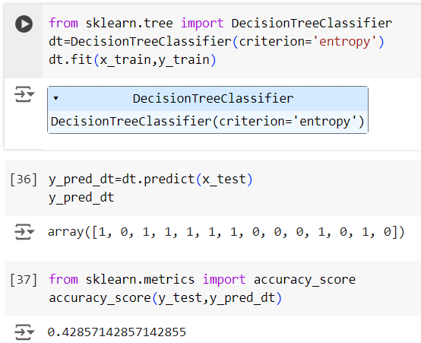

**­­­­­**

**Model Validation and Evaluation Report:**

|  |  |  |
| --- | --- | --- |
| **Model** | **Classification Report** | **Accuracy** |
| Decision Tree |  | 42% |